Personal details (please see our Trustee Privacy Notice)

Title:

First name(s):

Surname:

Address (for correspondence):

Post Code:

Date of birth:

Tel: Mobile:

Email:

Interest and motivation

- Please explain why you would like to apply to become a trustee of the Gloucestershire VCS Alliance.

- Please complete the skills audit table below in order for us to keep a record of individual areas of expertise and also more easily identify any gaps of knowledge on the Board overall which we may look to fill in the future:

Area | Direct professional experience | I know a lot | I know a little | Not my area at all
Governance
Finance
Charity/Company Law
Human Resources
Health and Safety
Data Management and Protection
Information Technology
Marketing and Communications
Fundraising
Strategy
Leadership
Membership and Stakeholder Involvement
Partnership Deals and Mergers
Risk Management

Employment history and current status

- Please list below, details of employment history including your current position and employer or your current status, e.g. retired. (You may wish to attach a separate CV to the application form).

Relevant experience

- Please provide any further information, including relevant memberships, skills, qualifications held or other expertise which you feel may be relevant to this application.

References
- Please supply us with the names and contact details of two referees that we may contact should you be offered the position.

Reference 1

Address:

Postcode:

Tel:

Email:

Reference 2
Name:

Address:

Postcode:

Tel:

Email:

DECLARATION
I declare that the information I have given in support of my application is, to the best of my knowledge and belief, true and complete. I understand that if it is subsequently discovered that any statement is false or misleading, or that I have withheld relevant information, my application may be disqualified, or, if I have already been appointed, that appointment may be revoked.

I understand and agree to be bound by the Constitution of the Gloucestershire VCS Alliance, its Trustee Code of Conduct and its Trustee Expenses Policy.

Signed___________________________________________

Name____________________________________________

Date_____________________________________________

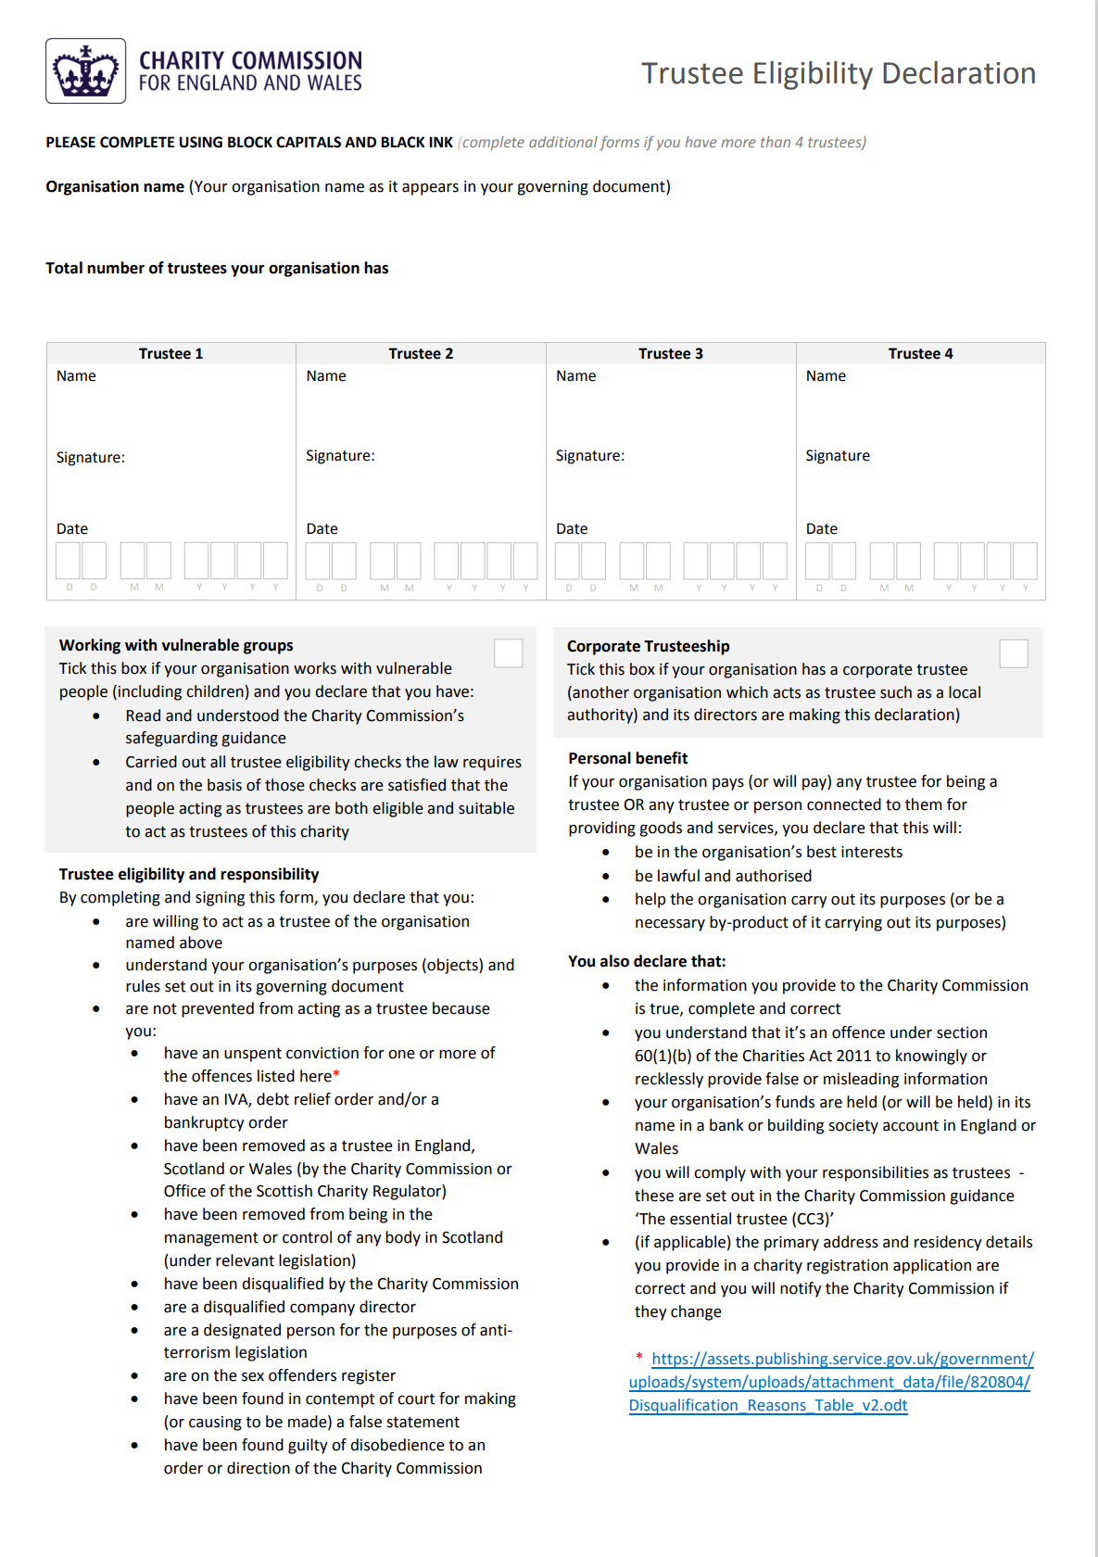

Thank you for completing this application form and for your interest in becoming a trustee of the Gloucestershire VCS Alliance.

This form should be marked ‘Confidential’ and returned to Chair of Trustees via one of the following:

E-mail: chair@glosvcsalliance.org.uk

Postal address:

Chair of Trustees
Gloucestershire VCS Alliance
Suite 4, Bank House
Abbey Terrace
Winchcombe
Cheltenham
GL54 5LL

